**Scenario planning and stakeholder mapping**

When one is approaching a change management project and following a PESTEL analysis involving a representative sample of a management team, we can adopt a scenario planning approach which enables us, in a collaborative way, to create three scenarios of the future and then, through a process of analysis and dialogue, create a fourth scenario which would be the most plausible blend of the three earlier scenarios. Scenario planning and analysis is a tool of strategic change management planning which takes the uncertainty of future developments into account.

Scenario planning is a process of creating alternative futures based on knowledge, research, and imagination. Scenario planning involves using alternative futures as devices for thinking about and assessing current, and future, strategies and actions. It benefits from involving a diverse group of stakeholders and knowledgeable parties. The future is not predictable and scenario analysis is not a process of “getting the future right”. The scenario planning process is a creative one and the steps involved are as follows:

1. Form the managers into groups of, on average, eight.
2. Key focus question: ‘what will our operating environment look like in five years’ time?’
3. With a clear question established, the next step involves assessing the previous analysis from PESTEL that might influence unfolding events related to that question.
4. Chunk down into the analytical materials and identify, as a group, what you feel are the meta-scenario change drivers that will influence the future operating environment.
5. Draw a two-by-two matrix and create four scenarios of the future environment (see the example below).

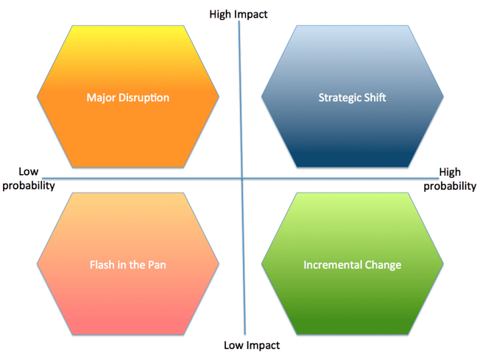

Then agree on a title for each of the scenarios created and populate these into each quadrant with a brief description. You can also mark the impact of each scenario as above, as an additional planning tool.

**Stakeholder Mapping**

A stakeholder is to be understood as any person or group who has a vested interest or stake in the effects and outcomes of the change project. An effective way to identify, filter and organise stakeholders by influence is through a stakeholder mapping exercise. Stakeholder mapping is the visual representation of stakeholder analysis. Stakeholder analysis should begin with a brainstorming session with your project group. Once you have identified the larger pool of stakeholders, you can begin to align them to their level of interest and involvement using visual aids such as a matrix. This process involves the following steps:

Step 1: Participants form into groups of 6 to 8

Step 2: They appoint a group facilitator.

Step 3: The facilitator provides post-it pads, flipchart stands and pads.

Participants adhere to the following process:

**Stage 1: Identifying stakeholders**

* Simply brainstorm all the stakeholders that you can identify that will have a stake in the change project.
* Write the name of each stakeholder on a sticky note.
* The facilitator must accept all suggestions and discourage any questioning of stakeholder suggestions at this stage.
* Post all stakeholder notes onto flip chart sheets.
* Remove duplications.
* If there seem to be different terms used for the same stakeholder group, the facilitator agrees with participants which one is to be used.

**Stage 2: Estimating the influence of stakeholders**

* Draw a line down the centre of a flip chart sheet and then another across its centre creating four quadrants.

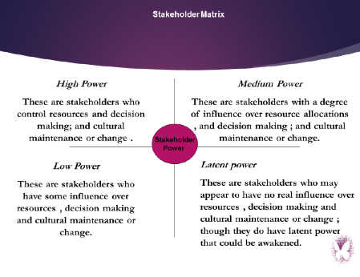

**Stage 3: Populating a stakeholder communication plan template**

In this stage, participants compose a stakeholder communication plan template using a flip chart to list each stakeholder and document their power status as well as the nature of their power. They note additional key interests that they may have as well as any issues that may be of importance to them. The communication vehicle to be used to engage with stakeholders can be agreed upon as well as the frequency.

The main aim of stakeholder mapping is to both unpack the interest a specific stakeholder group has in the change project and the degree of power and thus influence they have over its operation. It is important that the process of scenario planning, stakeholder mapping, and PESTEL analysis is treated as an analytical strategy to help understand the case for change and involve key stakeholders in both the diagnostic stage and the planning stage of a change project. These three exercises are interdependent and also must be addressed with a serious group mindset, to pay lip service would damage the enabling power of these techniques as change tools.

**Key Lessons**

Both scenario planning and stakeholder mapping are techniques that must be applied in a group context and after PESTEL analysis has been performed. The content of the three applications, including the interactive sense-making that the management team engaged with, when knitted together forms a cohesive base for collective decision making based on shared understanding. This then provides a solid foundation for building the case for change and the overarching change management programme. It is very important that as many stakeholders as possible share in this sense-making and strategic change project.